OSU KNOX COUNTY ALUMNI CLUB SUMMER NEWSLETTER - June 2022
2022-23 OSU Knox County Alumni Club Scholarships
The Ohio State University Alumni Club of Knox County has awarded $31,000 in scholarships for the 2022-23 school year. First year scholarship recipients are Caiden Moody, Abigail Dickhof, Shayla Wheeler, Andrew White, Kennedee Plank and Allenah Boeshart. Current student recipients are Sarah Lord, Samuel Bassett, Brianna Small, Georgianna Caputo, Heath Myers and Alyssa McElhatten.
Moody of Fredericktown is a graduate of Clearfork High School and will receive the club’s “Big Ten Thousand” scholarship. He will be a neuroscience major. Dickhof of Centerburg is a Centerburg High School graduate and will major in dietetics. Shayla Wheeler of Utica is a Utica High School graduate and will major in health sciences. Andrew White of Mount Vernon is a Mount Vernon High School graduate and will major in computer science and engineering. Kennedee Plank of Mount Vernon is a Mount Vernon High School graduate and will major in English. Alenah Boeshart of Danville is a Danville High School graduate and will major in Crop Management and Soil Conservation.
Current student Lord is a chemical engineering major. Bassett is a neuroscience major. Small is a nursing major. Caputo is a world politics major. Myers is engineering major. McElhatten is a nursing major.
The scholarships are merit based and awarded annually to entering students and currents. Alumni.alumni.osu.edu/Applications are taken in January through Scholarship Universe. The club has a long history of assisting students. Contact us through our website www.osuknox.alumni.alumni.osu.edu/scholarship
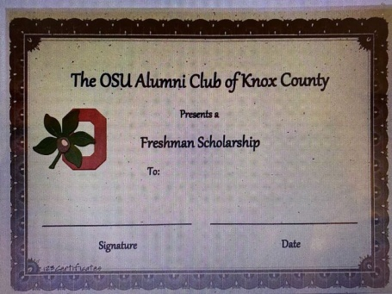

2022 Buckeye Spirit Event Scholarship Fundraiser
Returning after a 3 year hiatus due to “Covid 19” we are delighted to announced the Buckeye Spirit Event is being planned for Tuesday, October 18th at The Glenn H. Gallagher Center in Mount Vernon, Ohio. The Keynote speaker will be Coach Bill Conley a nationally known top college football recruiter in America plus a former OSU Football player himself under Coach Woody Hayes and also an OSU football team recruiter for 17 years working under OSU Coach Earle Bruce, Coach John Cooper and Coach Jim Tressel. Mr. Conley was the head football coach at Ohio Dominican University where he took an upstart D2 college program to national prominence. He might share a few thoughts about his Ohio State team’s ultimate accomplishment….winning the Fiesta Bowl and the undisputed National Championship in one of the most incredible college football games in history. There will also be an appearance by The Best Dam Band in the Land, and tail gate dinner, silent and live auctions and more. Be sure to mark your calendar….. Watch for additional information and special mailings. If you have moved recently and/or changed your phone number you can notify us to update your information at our email: knoxcoclub@osu.edu

Future Alumni Recognition
Plans are underway to recognize our recent scholarship recipients at a “Future Alumni Recognition” luncheon on Sunday August 7th. The recipients and their families are invited to join us at a special recognition before departing to their first day of classes. Students will be receiving more information about this event over the next few weeks. We thank our Club members for donations and support of special events like the BSE that enable our Club to provide local students with scholarships to attend The Ohio State University.

Real Money. Real World. - May 19, 2022

The Real Money. Real World. simulation was held on May 19, 2022 at Mount Vernon Middle School for all 8th grade students. RMRW is a financial literacy program for youth sponsored by Ohio State University Extension. Prior to the simulation students are involved in four preparatory classroom lessons. The simulation involves students visiting thirteen tables to make decisions concerning real world expenses at the age of 27. The students visited child care, insurance, transportation, clothing, entertainment, food and others to make decisions based on real world scenarios. The simulation requires numerous adult volunteers to help the students make those decisions. The OSU Alumni Club of Knox County provided (7) many of the volunteers, this year.
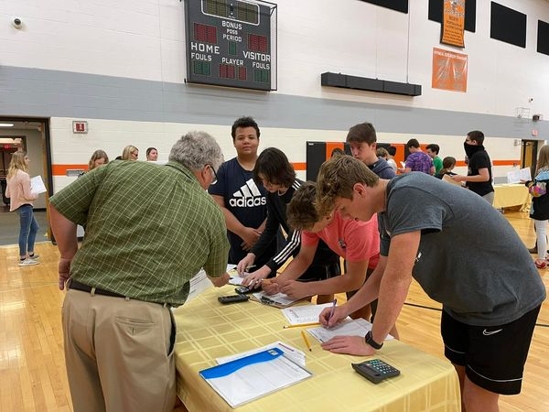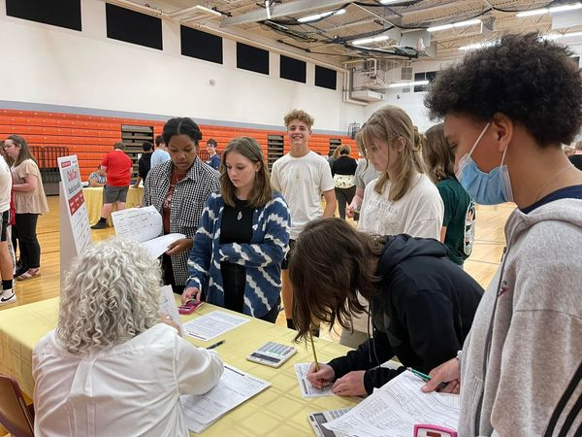

Hey there! Can you help?
Your OSU Knox County Alumni Club Board is asking for some extra volunteers to help with the upcoming BSE….. maybe you will consider helping out … we are in need of donations of members to help with silent auction, set up for the event….if you can help or have questions please drop us an email at: knoxcoclub@osu.edu

Is this really you?
In our quest to reach out to members we have discovered several of you have ‘ditched’ your landlines and are using only your cell phones. This seems to be a wave of the future for a variety of reasons. We also have discovered several of our members have moved! In hopes of personally inviting every member to the October BSE we are asking each of you who has moved, changed your phone number and/or changed your email address to please let us know…. Please send us an email at : knoxcoclub@osu.edu with your updated info so we may update our records or you may complete this membership form and send to us with the information. We usually have membership renewal at the BSE but knowing your current mailing address and/or email now will help us get in contact with you to send invitations to our OSU Knox County Alumni Club events.
(add Club membership form)

